|  |  |
| --- | --- |
| **Name :-** | Aryan Dilipbhai Langhanoja |
| **Enroll No: -** | 92200133030 |

## Cockpit warning light control using basic logic gates

* **Aim** :-

To construct a cockpit warning light control system using the generalized simulator. The users will be able to state the output condition for given set of combinations of input. The users will be able to select the correct Boolean expression for given combinational circuit.

The user will be able to construct and simulate the cockpit warning light control system and verify the results with the generalized simulator.

* 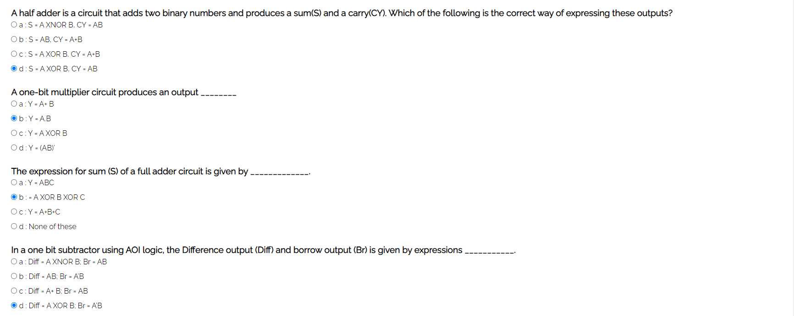**Pre-test :-**
* **Simulation :-**

**Task :-** Construct and verify XOR logic using basic logic gates.

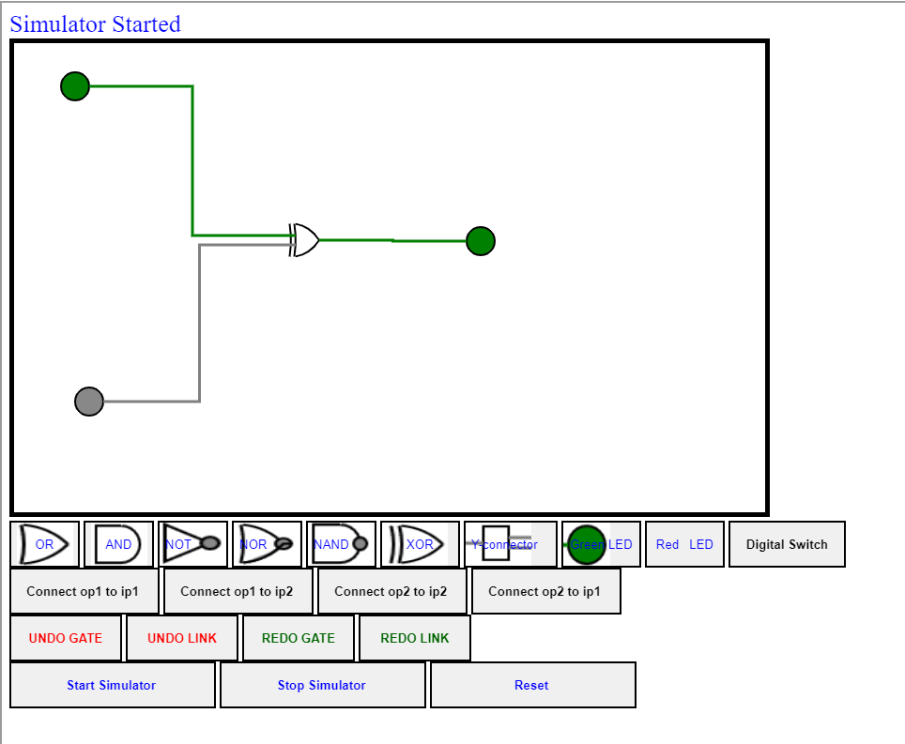

* **Post-test :-**

